Brushes Whitefire Cast

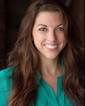
Ashley Taylor (Woman #1)

Ashley appeared in the staged reading of “Brushes” at Theatre West, and is super-duper excited to be included in the World Premiere with this most illustrious cast of crazy characters (and by that she means the real people). She is an actor, playwright and producer, and a member of Theatre West. There, she most recently played Grace in the political thriller, THE LEATHER APRON CLUB, herself in two volumes of the SUNDAY AT SEVEN monologue series, and is currently working on a one-woman show, WOMAN OVERBOARD, written and directed by Lloyd Schwartz. She wrote and appeared in the web series THE KEEPERS and played an evil stepsister in the TV Show, SCARY TALES. In her other life, Ashley is a teacher, wife of Stephen, and mom of Killian (who appeared with her in the winter show JOLLY HOLIDAYS). She’s a proud Ravenclaw & Team Taylor for life!
Thank you, Cathy, Carol, & Kevin.

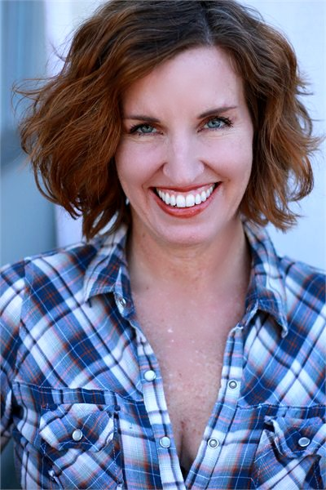

Heidi Appe (Woman #2)

Heidi is thrilled to be part of the craziness. Having been part of the staged reading in 2018, Heidi is very excited to part of its world premiere. Favorite roles include Anjenai in Flash Gordon- the Musical: the Play, an awful Jane Russell impression for The Golden Age of Radio, Gymnasia, A Funny Thing Happened on the Way to the Forum, Veronica, God of Carnage (nom, Broadway World Awards), Mrs. Meers, Thoroughly Modern Millie. Often finding herself undead, evil, and/or crazy, Heidi has served as various horror characters for live events and film. Recent projects: No Problem (in post), Debt of a Salesman (winner, Portland Comedy Film Festival), Extreme Measures, The Shoaks, Long Island: South Shore. Heidi’s short play I’m Next has been produced at the Whitefire Theatre and for the Hollywood Fringe Festival. Look for her web short, How You Think You Look.

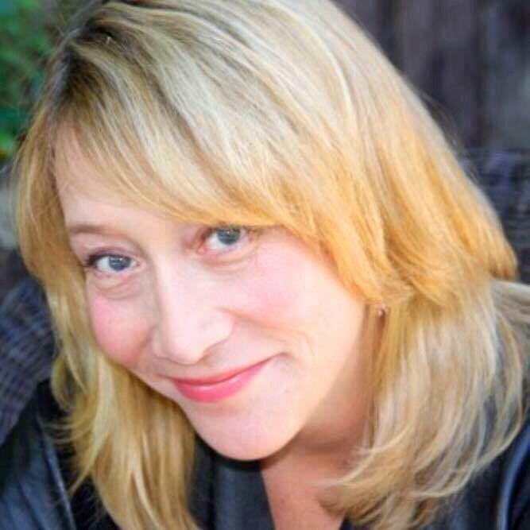
Amy Smallman-Winston (Woman #3)

Amy Smallman-Winston was born and raised in Indiana. As long as she can remember she wanted to be in show business. After graduating from the American Academy of Dramatic Arts in NYC, she moved to Los Angeles to pursue her creative dreams. Soon after she joined Academy Award winner Bobby Moresco's Actor's Gym, where she has been an active member for over 20 years. Amy is also a proud alumnus of The Groundlings Theater, where she honed her improv and sketch comedy skills. Original theatrical works include her one-woman show Miss Congeniality, and Whores, co-written with Maggie Baird. Her theatre credits include the LA premieres of Blackout, Cheyenne, Stella’s Last J Date and American Conspiracy.

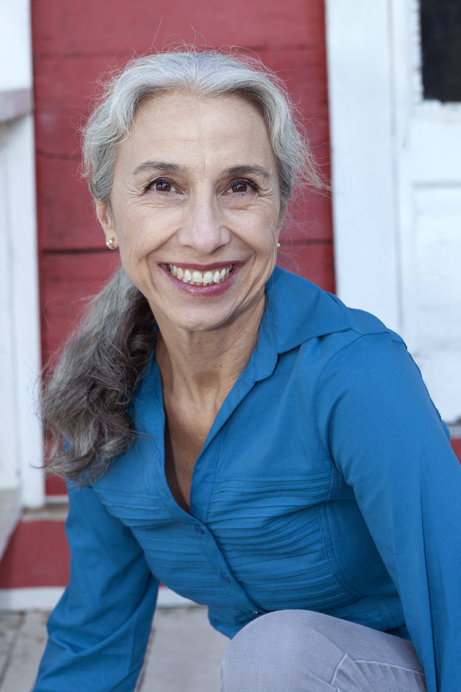

Clara Rodriguez (Woman #4)

Clara Rodriguez is a member of Theatre West and recently performed as Emily in the Eclipse Theatre's production of And Then There Were None. Favorite roles include Mary in How the Other Half Loves and Myrtle Brown in Morning's at Seven. Clara has a background in improv and has performed with Theatre Sports Los Angeles, Pulp Playhouse, Galorama, Brain Trust and lots of other improv companies. She dedicates her performances to Brian, Riley and Addie who have very nice hair, but that's not why she loves them.

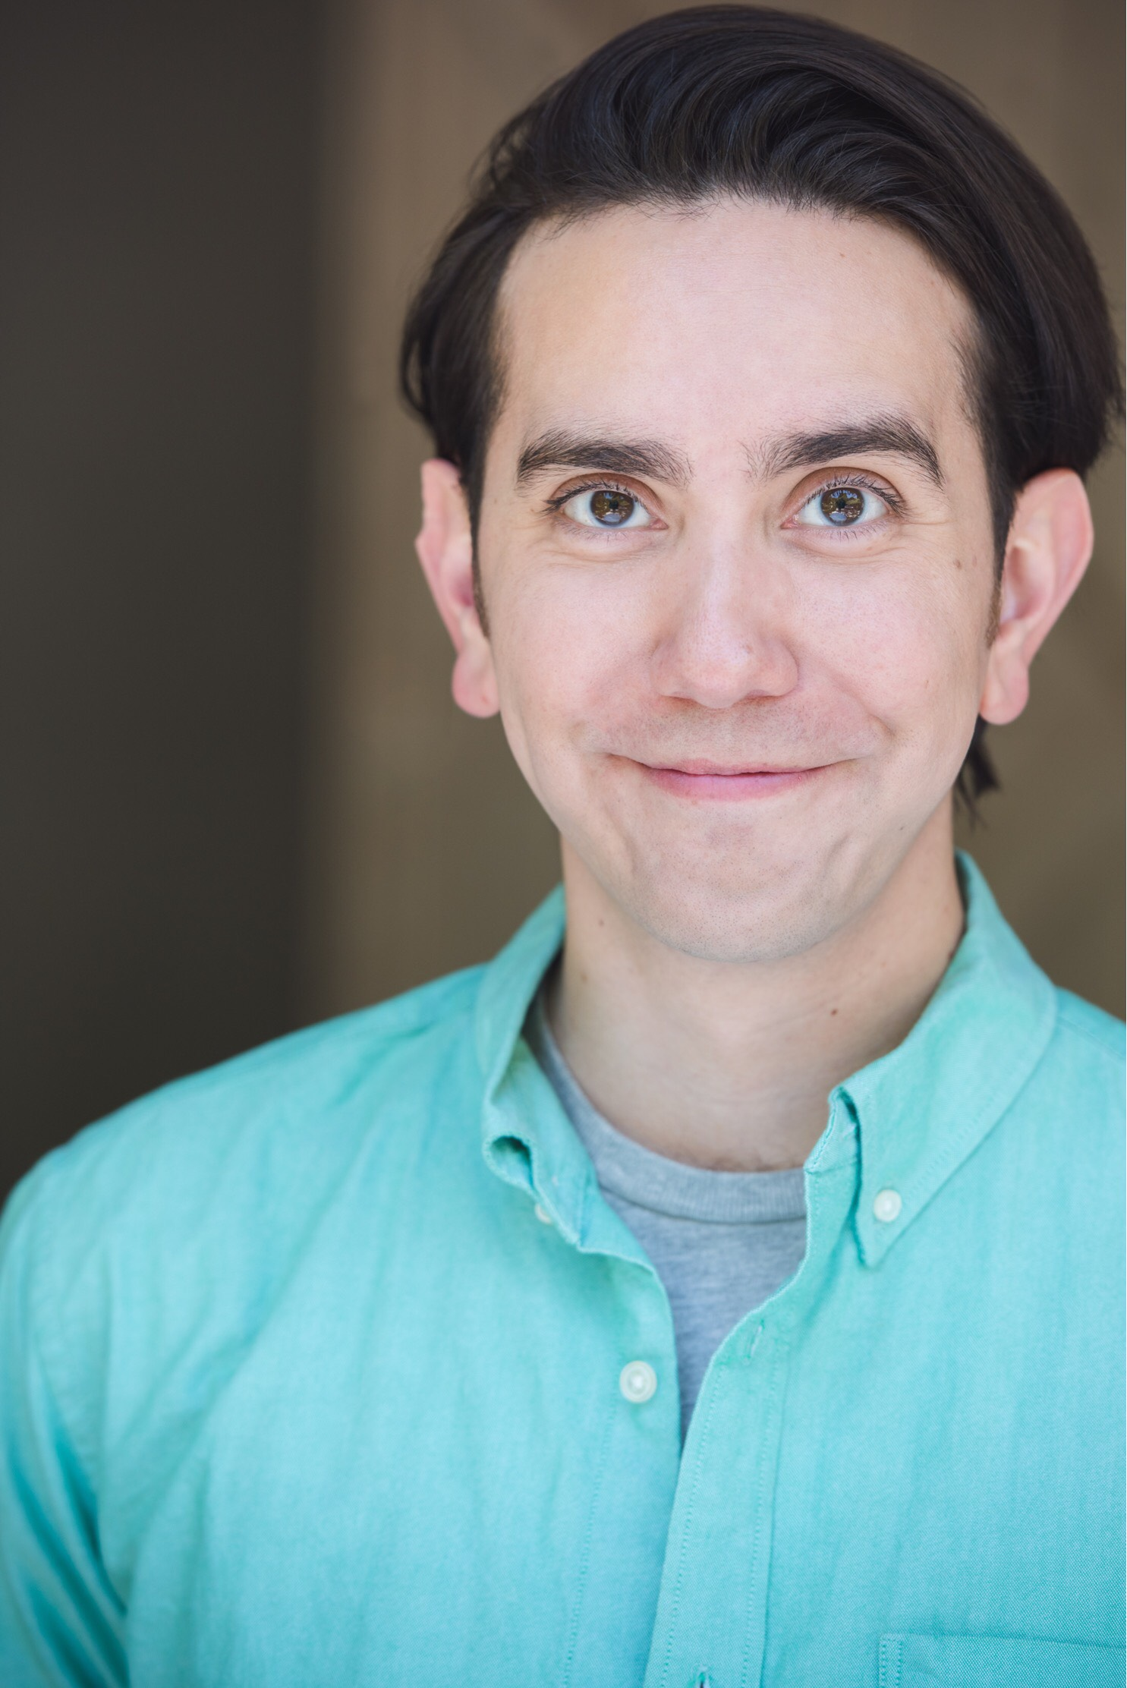
ANDREW VILLARREAL

Proud graduate of Texas A&M Int'l and the American Academy of Dramatic Arts, Andrew is honored to have appeared in the staged reading of “Brushes” at Theatre West and—after many hair consultations—join the fantastic team of the first full production at The Whitefire. Villarreal has been acknowledged with Year's Best Performance for his work as Arnold Beckoff in Theatre Out's Torch Song Trilogy (Stage Scene LA). Past recognitions also include Best Actor wins for The Rocky Horror Show (Stage Scene LA) and Equus (Santa Monica Theatre Guild). Andrew recently completed work on the indie “little drama that could” Artificial Flowers and the comedy web series, Kaplan’s Korner-Best Comedy Winner, Festigious Int’l Film Festival. With every strand of hair on my head, Thank You Cathy, Carol and Kevin for inviting me to be a part of the family.

